**Description of the project**

This project analyzes financial datasets, determining anomalies and maximum gain. The financial data used here in this program is for apple stocks.

**Structure of the code with diagram and comments**

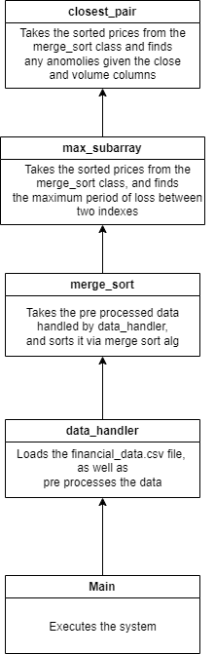

**Instructions on how to use the system**

To use this system, all you would need to do is to execute the main script, which will automatically perform analysis on the data.

**Verification of code functionality**

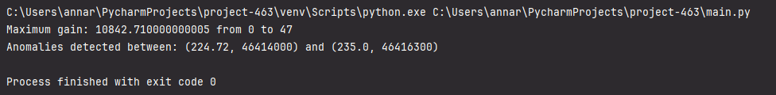

**Discussion of findings**

This system could use a graphical user interface for selecting which kind of analysis to perform on the data.